SOFTWARE ARCHITECTURE

Project number / Title | MT_ONE_0023 / miRFlow

Version Control
Version | Description |  | Date  (dd Mmm yyyy) | Author
v0.01 | First draft for circulation
v1.01
APPROVAL
Name | Organisation | Position |  | Signature / Date
PI’s name | Imperial College | Principal Investigator

CONTENTS
References 3
1. INTRODUCTION 5
1.1 Scope 5
1.2 Definitions, Abbreviations and Conventions 5
2. ARCHITECTURE OVERVIEW 5
3. DEVICE ARCHITECTURE 6
3.1 Architecture rationale 6
Performance 6
Safety 7
Usability 7
SOUP Integration 7
Other Requirements 7
3.2 Functional Requirements Table 7
3.3 Hardware Components 7
3.3.1 Hardware Component 1 7
3.4 Software Components 7
3.4.1 Software Component 1 7
3.5 SOUP Items 7
3.5.1 SOUP Item 1 7
4. DIAGRAM 8
5. WORKFLOW 8
5.1 Work Flow 1 8
5.2 Necessary Segregation (Class C only) 8

References
Ref/ID | Title
IEC 62304:2006 | Medical device software — Software life cycle processes
BS EN 62304: 2006 + A1 2015 | Medical device software — Software life cycle processes
FDA Guidance | Off the shelf Software use in Medical Devices

Ref/ID | Title
QSP005 | Risk Management
QSP019 | Software LifeCycle processes inc Design and Development
 | Design Brief, Meeting minutes, Interface overview

INTRODUCTION

Scope
This document presents the architecture of XXX software.

Definitions, Abbreviations and Conventions
Any definitions or abbreviations, or convention
Example:
Terminology/ Abbreviations/ Acronyms/ Definitions | Meaning
AWS | Amazon Web Services
PHI | Protected Health Information
BLE | Bluetooth Low Energy
VCS | Version Control System
CPU | Central Processing Unit
OS | Operating System
PC | Personal Computer
USB | Universal Serial Bus
RCR | Risk Control Requirement (cf risk analysis)
SRS | Software Requirement Specification

ARCHITECTURE OVERVIEW
The architecture is used to transform the requirements for the medical device software into a documented architecture that describes the software structure and identifies the software items.
Provide an overview of the architecture. This should include a description of the system, including who the users are, a description of the environment of use, the main functions, inputs and outputs and any interfaces between the software items and the components external to the software items (both software and hardware). Refer back to the Design and Use specification for the project.
Example #1: The software architecture consists of only one architecture diagram. The following document should be read in conjunction with this document.
Document: Architecture Design Chart
Example #2 The software architecture is split into 3 high-level components:
- A wearable device, with multiple programmable micro-processors
- A software platform, which is cloud-hosted
- A user interface, which is split into three individual applications
The following architectural diagrams should be reviewed in conjunction with this document:
- Document: Architecture Design Chart_ Platform
- Document: Architecture Design Chart_ Wearable
- Document: Architecture Design Chart_ UI

DEVICE ARCHITECTURE

Architecture rationale
Explanation of the software/hardware architecture in terms of all architecture related requirements, with a justification of the design of hardware/software architecture to allow fulfilment of those requirements. Include:
- required performances
- safety (linking these to risk control measures and misuse mitigation. Include a list of the risk mitigation/risk control measure where these involve the architecture and how the architecture reduces/mitigates the risk (use before and after diagrams may be used)
- usability Usability Engineering outputs related to software architecture
- SOUP integration,
- other established requirements (for example security (redundancies, emergency stop, recovery), storage, availability, regulatory requirements (in particular Data Protection and Health Information privacy), where these are dependent on the architecture. Include any network related architecture characteristics if this is applicable.
Example #1: The platform is responsible for:
1) Managing TCP/IP connections from wearable devices
2) Providing a REST interface to the user interfaces

A platform architecture diagram is included in Document: Architecture Design Chart_ Platform.

Across the platform, the architecture is organized into micro-services, where each micro-service has a single area of responsibility. Multiple architectures were considered when designing the platform, including SOA. This was considered in the context of the product function and the nature of a medical device.

It was crucial to maximise reliability and availability, while ensuring maintainability and testability.
A micro-services architecture was selected, based on a risk management approach, for the following reasons:
1) It is easy to scale, as the number of wearable devices transmitting increases. Micro-services can horizontally scale
2) It is easier to test, as the test surface is smaller. Each of the micro-services don’t do as much as a single, large monolithic application and thus they can be tested locally
3) Less susceptible to failure. Failure of a single micro-service will typically lead to degradation rather than downtime
4) Cheaper, commodity hardware. Horizontal scalability means the platform can be deployed across low-cost x86 server instances as opposed to proprietary, vertically scaled servers
5) Easier to deploy changes. Micro-services can be hot swapped without causing downtime and the small size of micro-services make deployments extremely fast.

Performance

Safety

Usability

SOUP Integration

Other Requirements

Functional Requirements Table
Use a table to list the functional requirements (from the Technical Requirement Specification) that the software fulfils and link each function to the component that is used to implement the function (list the main component only).

Hardware Components
Describe the hardware components on which the software runs, as well as the interactions between components. Use component/deployment/network/interface diagrams.

Hardware Component 1
Describe each component. For class C, the description must contain the identification, software components received, technical characteristics, network hardware interfaces.

Software Components
Describe the software components and their interactions as well as the required operating systems. Use diagrams to present this information.

Software Component 1

SOUP Items

SOUP Item 1
Describe the SOUP items (identification, version, origin)
Specify the functional and performance requirement for the SOUP item that are necessary for the intended use (which SOUP functions are used). Include any interfaces and integration method. Identify any documentation required for COTS items.
Specify the system hardware and software necessary to support the proper operation of the SOUP item.
List any known bugs for COTS items. These should be reviewed to assess whether they can affect the user and user/patient safety (the review should be documented as a risk review that is referenced here, and refer to the software FMEA or risk analysis to manage those as part of the project risk management.

DIAGRAM
Insert the architecture diagram(s) below or create a separate document and refer to it in the sections above as shown in the examples. Break the architecture down into multiple diagrams if necessary.
Example #1:
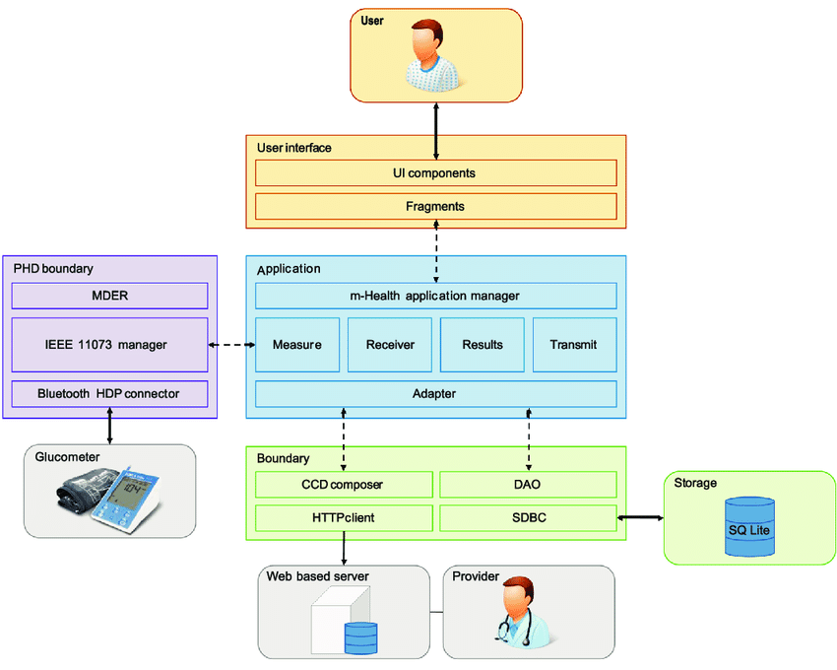

WORKFLOW

Work Flow 1
Use workflow/sequence diagrams to describe each software functions listed in the table in section 3.

Necessary Segregation (Class C only)
Specify the segregation necessary for risk control and define how the team will ensure that such segregation is effective.

